Project Design Phase-II
Data Flow Diagram & User Stories

Date | 31 January 2025
Team ID | LTVIP2026TMIDS76616
Project Name | HematoVision – Advanced Blood Cell Classification Using Transfer Learning
Maximum Marks | 4 Marks

Data Flow Diagrams:
A Data Flow Diagram (DFD) is a traditional visual representation of the information flows within a system. A neat and clear DFD can depict the right amount of the system requirement graphically. It shows how data enters and leaves the system, what changes the information, and where data is stored.
Example: DFD Level 0 (Industry Standard)

Example: (Simplified)

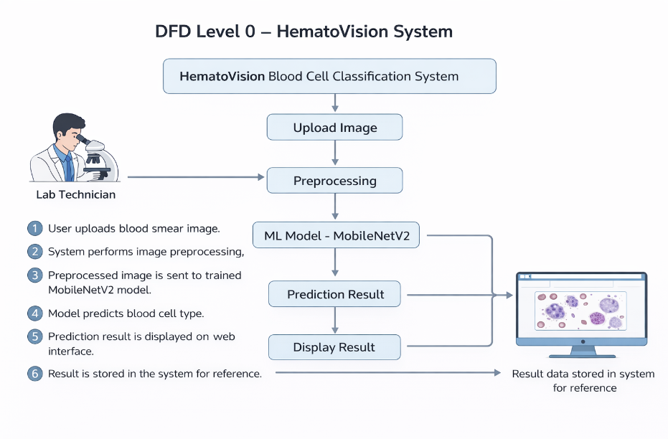
User Stories
Use the below template to list all the user stories for the product.
User Type | Functional Requirement (Epic) | User Story Number | User Story / Task | Acceptance criteria | Priority | Release
Lab Technician | Image Upload | USN-1 | As a lab technician, I can upload a blood smear image for classification. | Image should upload successfully and preview before prediction. | High | Sprint-1
Lab Technician | Prediction | USN-2 | As a lab technician, I want the system to classify the uploaded image automatically. | System should display predicted blood cell type with confidence score. | High | Sprint-1
Lab Technician | Result Display | USN-3 | As a lab technician, I want to clearly view the prediction result on the web interface. | Result should show blood cell type and probability percentage. | High | Sprint-1
Pathologist | Accuracy Validation | USN-4 | As a pathologist, I want high accuracy predictions to assist medical diagnosis. | Model accuracy should meet predefined performance standards. | High | Sprint-2
Pathologist | Quick Report | USN-5 | As a pathologist, I want faster prediction results to reduce patient waiting time. | Prediction should generate within few seconds. | High | Sprint-1
Administrator | Model Management | USN-6 | As an administrator, I can update or maintain the trained ML model. | System should allow model update without system failure. | Medium | Sprint-2
Administrator | System Monitoring | USN-7 | As an administrator, I can monitor system performance and logs. | System logs should be accessible and properly recorded. | Medium | Sprint-2

